
ATAR CHEMISTRY UNITS 3 AND 4
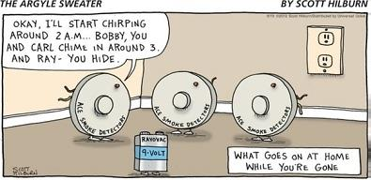
Extended Response: Electrochemistry

Weighting: 5%

Validation Test Date: Friday, 15 May (Week 3)
(Howard 2013)

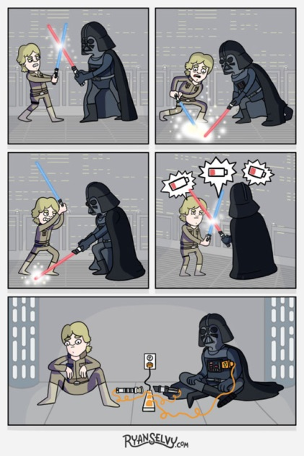
- Draw up a table that will include the following information about the dry cell (a primary cell), the lead-acid cell (a secondary cell) and the alkaline hydrogen fuel cell. Under the table draw a fully labelled diagram of each of the electrochemical cells previously listed.

- What is the anode composed of?
- What is the cathode composed of?
- What is the electrolyte?
- Write the oxidation half-equation.
- Write the reduction half-equation.
- Write the overall, balanced redox equation.
- What voltage is this cell capable of delivering? Show all working.
- Outline three benefits of using this electrochemical cell.
- Outline three disadvantages of using this electrochemical cell.
- List two environmental impacts of using this electrochemical cell.

(LoganDX 2015)
- Complete Lucarelli ‘Essential Chemistry ATAR Chemistry Units 3 + 4’ Set 12 (pg 90) questions 2 – 12.

- You must include correctly referenced sources you have used to get information (you must use at least four sources).

Bibliography
Howard, D. “Handyman Humour 2.” Howie's Handyman Services. 29 May 2013. http://www.howieshq.com/howies-blog/handyman-humour-2.html (accessed April 1, 2016).
LoganDX. “If Lightsabers Ran on Current Power Sources.” Don't Hate the Geek. 3 September 2015. http://donthatethegeek.com/if-lightsabers-ran-on-current-power-sources/ (accessed April 1, 2016).
mmgteacher. “MMG's English Blog at PMCurie.” Edublogs. 2 December 2013. http://englishblogmmg.edublogs.org/tag/humour-2/page/30/ (accessed April 1, 2016).


(mmgteacher 2013)

